Morro Bay Winter Bird Festival – Museum Sponsored Events
Friday Jan. 13, 2006
Bird Adaptations 101 -- 10:45am-12:l5pm Natural History Museum -- Explore some distinctive physical adaptations that enable birds to survive. Join State Park Docent Louise Abbott, who will discuss such features as birds’ beaks, feet, and feathers. Beginning birders. | Discover Magnificent Morro Rock -- 1:00pm – 2:45pm Community Center -- Join State Park Docent Rosemary Olszewski to explore the “Gibraltar of the Pacific” and hear about its history and geology. View the many species living in its shadow and learn what we can do to help them survive. Dress for windy, cool weather. Caravan.
Morro Bay -- The Intersection Of Nature & Man -- 1:00 pm-3:00pm Natural History Museum -- Join engineer and Cuesta College instructor John McCabe to learn about how the Morros and Morro Bay were formed. Topics will include the geological formation of Morro Rock, the coastal erosion and sand drift that formed the sand spit, and how the resulting bay and drainage system nurtured the development of the estuary. Discover why this estuary has become such an important stop on the Pacific Flyway.
Sat. Jan. 14, 2006
Birds From The Balcony -- 10:00am-12:00 noon Natural History Museum -- Join Morro Bay State Park Museum Manager and Interpreter Rouvaishyana on the museum balcony overlooking the Morro Bay Estuary to watch birds around the Bay. Geared to families, and the casual or infrequent birdwatcher, but serious birders will see interesting birds as well. Meets rain or shine. | Great Bird Illustrators -- 10:l5am-12:00 noon Natural History Museum -- View the works of John James Audubon, John Gould, and Luis Agassiz Fuertez – all 19th century artists and ornithologists - who continue to inspire both the active and armchair birders of the 21st century. Using colorful reproductions of their work, State Park Docent Marion Enfield will discuss their works as visual reflections of 19th century culture.
Ancient Birders Of The Central Coast -- 1:00pm-2:30pm Natural History Museum -- Birds were an important part of the native Chumash and Salinan cultures. Join State Park Docent Tyra Solomon who will discuss and illustrate the Native American’s relationship with the eagle, falcon, cormorant, owl, and others. | Estuary Talk & Walk -- 2:30pm-4:00pm Natural History Museum -- Explore Morro Bay Ecosystems with State Park Docent Evelyn Dabritz, starting with a presentation at the Museum of Natural History, and then a stroll to the “Heron High-Rise,” the “Mudflat Cafe” at Windy Cove, and the panorama at White Point.
Sun. Jan. 15, 2006
A Bird’s Eye View -- 10:30am-12:00 noon Natural History Museum -- The lives of birds depend on what they see and how they are seen. Listen while State Park Docent Bob Field explains how the behaviors of predators and prey are affected by characteristics of their vision and visibility. Learn how vision evolved and how it influenced the evolution of colors and patterns of plants and animals. | Meet The Sea Otter -- 1:00pm-2:30pm Natural History Museum -- Join State Park Docents Ray Easton and Dick Evans for an “edutaining” program focusing on sea otters and elephant seals, two of the marine mammals that inhabit the Central Coast.
Mon. Jan 16, 2006
Mind Walk -- There Are No Snakes In Ireland -- 10:l5am-12:00 noon Natural History Museum -- A photographic record of a trip to Ireland by Dick Boyd emphasizing its natural history, especially birds, and its other beauties and antiquities as well. Yes, there are no snakes in Ireland, legend having it that St. Patrick drove them out. However, in spite of its proximity to Britain and the European continent, there are also no woodpeckers in Ireland. These and other curiosities will be discussed and a hunt for the declining and elusive Corncrake and Red Grouse described. Dick Boyd lives in Morro Bay and is retired from an academic career teaching engineering. | 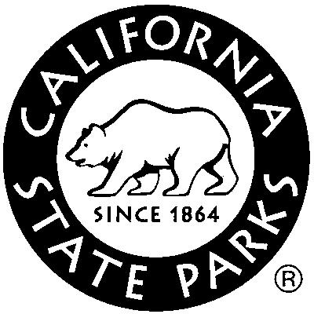  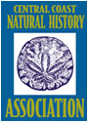  The Great Blue Herons Of Morro Bay -- 1:30 pm-2:30pm Natural History Museum -- Learn about the courtship, nesting habits, anatomy and behavior of the Great Blue Herons, Great and Snowy Egrets, Black-crowned Night Herons and the Double-crested Cormorants with State Park Docent Louise Abbott.

