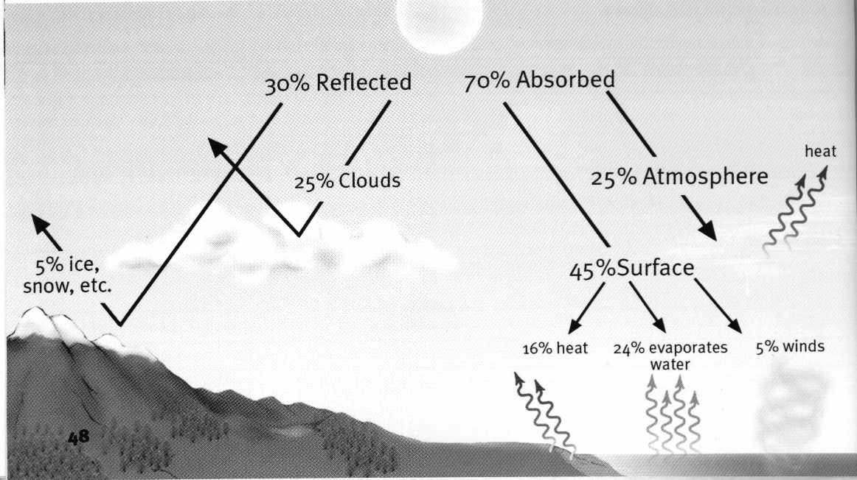
He

Ice/Snow
Clouds
O

O

H

C

O

O

N

N

O

O

Light wave

Heat wave
Heat wave
Each student assigned to: Sun, Earth, Clouds, Ice/Snow, H2O, N2, O2 CO2, He, Light/Heat wave (each holds up 8.5x11 paper labels)

Arrange chairs as shown

Light wave person travels from Sun to Earth, interacts with all elements; absorbed and converts into Heat waves; repeats until all elements encountered (See Sussman figures p. 48, 52)

Learn: Shortwave Light waves that are not reflected from clouds or ice/snow, or absorbed in atmosphere, pass through atmosphere to Earth’s surface. Resultant Longwave radiated Heat waves are reabsorbed by H2O and CO2 and reradiated.., otherwise radiate back into space. All energy entering the Earth, leaves the Earth.

Rev. 7-8-02 5:35pm

