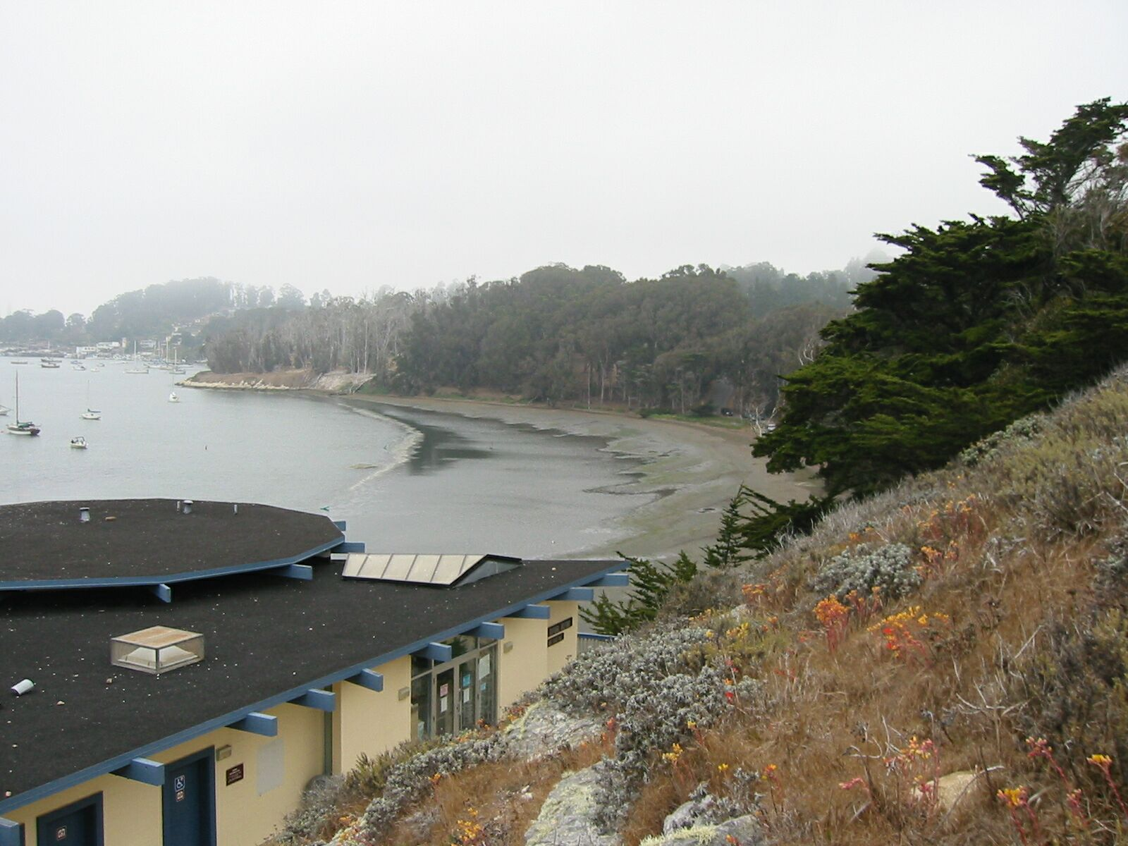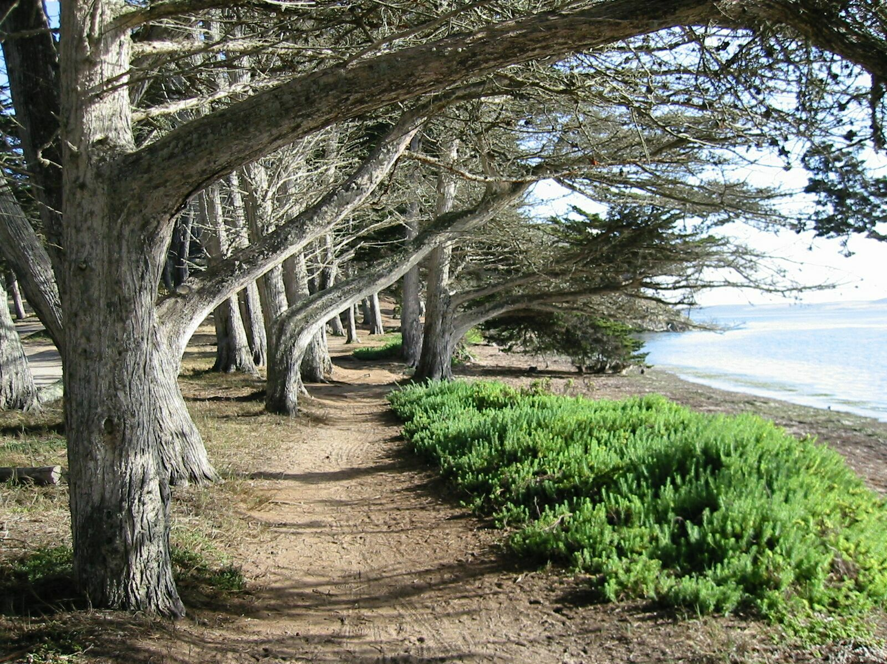
ADVENTURES WITH NATURE

Join State Park Docents for Half-Mile, Half-Hour,
Family Friendly Walks*

Every day at 2 p.m.
August 4 - September 2

Starting from the Morro Bay Museum of Natural History
State Park Road, Morro Bay

It’s Free!

Beachcombing in Windy Cove
An introduction to things that live in the Estuary!
or

Walk to White Point for Wonderful Bay Vistas

Experience the forces that shape the Morro Bay landscape!

*A responsible adult must accompany all children.
Wear warm clothing—it can be windy!
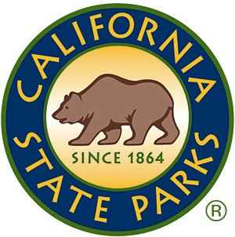
Call the museum at 772-2694 for more information.

