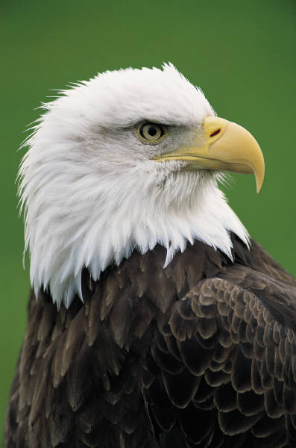

“BALD EAGLE
REINTRODUCTION ON SANTA CRUZ ISLAND”

By
Jessica Dooley

October 18, 7:00 PM
Congregational Church
11245 Los Osos Valley Rd
San Luis Obispo

Jessica Dooley, Field Coordinator for the Bald Eagle Reintroduction Program on Santa Cruz Island, will address the Morro Coast Audubon Society. She will include the history of the program, breeding successes and failures, toxic accumulation, captive breeding programs serving the project, satellite data from birds that have left the refuge, to the 11 chicks that will be released this fall. The presentation will include excellent power point stills and video, gathered from the solar powered video cameras in the hack boxes.

Jessica is a perceptive and dedicated biologist and a great speaker. Please join us.

7:00 PM Forum: Optics
Bring your optics and try others for a sharing experience.

MCAS meetings are always open to the public. Raffle and refreshments. Audubon members will be on hand to discuss memberships and internship opportunities. For further information, call 528-4587.

