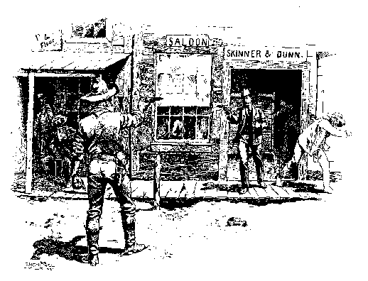

The 1892 Cayucos Bank Hold-up

In August 1892, a man named Dunn stole a horse that he attempted to sell in Paso Robles. San Luis Obispo Constable Peter Banks, a fearless, one-armed lawman was in Paso Robles on business and caught Dunn in the act of selling the horse. Constable Banks promptly arrested Dunn and began the ride back to San Luis with Dunn in tow as his prisoner. At Santa Margarita they stopped for a meal. After dining, Dunn, who was already "ugly with drink", began demanding whiskey. Constable Banks, who was alone and one-armed, decided to buy Dunn a bottle to keep him pacified and hopefully incapacitated.

Having resumed their ride back to San Luis, Dunn asked, "Banks, I'm in a hell of a fix, ain't I?" Constable Banks replied he was. Dunn then offered information in exchange for leniency. He revealed that he and three other men named Bill Brown, Goss and Isom were planning to carry out a series of hold-ups of Port Harford, Santa Margarita and the Cayucos branch of the County Bank. Dunn revealed that the Cayucos Bank robbery was planned for the evening of August 30th, 1892. The gang's plan was to go to cashier J. J. Simmler's home, feed him a story about a sick woman to gain entry to his home and then force Simmler to go to the bank and open the vault. The gang anticipated netting about $3,000.00 from the crime. Upon reaching San Luis, Dunn repeated these details before Sheriff E. F. O'Neal. Satisfied the information was solid, Sheriff O'Neal released Dunn with instructions to keep quiet and "play the game" with the gang until the night of the robbery.

On the evening of the robbery, Sheriff O'Neal, Deputy Sheriff A. C. McLeod, Constable Banks and Deputy Constable Kues traveled to Cayucos to make preparations for apprehending the bandits. They informed Cayucos Bank cashier Simmler of the plot. Simmler then transferred the bank's gold to James Cass' safe. However, Simmler was not willing to participate in the ruse and was replaced by Will Waterman who awaited the bandits at Simmler's home.

1892 Cayucos Bank Hold-Up, continued:

By this time several Cayucos residents had taken notice of the increased law enforcement presence in town and soon turned out with their own guns. The Sheriff warned them to take cover as shooting was anticipated. James Cass armed himself and took cover in a nearby woodpile. In setting up the stakeout on the bank, Sheriff O'Neal and Deputy Constable Kues got cold feet and refused to be inside the bank when the robbers entered. They were stationed in the back yard of the bank while Constable Banks and Deputy Sheriff McLeod took a position in a side room within the bank.

At about 12:00 Midnight bandits Bill Brown, Goss, Isom and a fourth man [Dunn?] arrived in Cayucos and donned gunny sacks with holes cut out for their eyes and arms. Just as Dunn had foretold, the gang went to bank cashier J.J. Simmler's home to abduct him. When Waterman told them that Simmler was out of town, they asked him if he was in charge of the bank. When he replied yes, the bandits took Waterman hostage and forced him to open the bank. The fourth man refused to enter the bank and remained outside, probably acting as a lookout. Following the plan, Waterman pretended to unlock the vault, the combination of which had been pre-set to open, and then jumped for safety behind the steel door. Banks and McLeod immediately rushed into the room and commanded the robbers, "Hands Up!"

Robber Bill Brown pulled his pistol and fired, his bullet striking a doorframe. Deputy McLeod was winged by the bullet, fell against Banks and exclaimed, "I'm shot!" Constable Banks had been covering the other two robbers, Goss and Isom, but now he knew that he must shoot Brown or be killed. He fired and struck Brown who collapsed on the floor. Seriously wounded, Brown managed to snap off another shot, striking McLeod a second time, this round striking him in the back. During the fight a candle that was illuminating the bank’s interior was blown out and the room was plunged into darkness. Goss and Isom took advantage of the darkness to run from the bank. They escaped on two horses that had been tied to a nearby hitching post.

Upon hearing the gunfire inside the bank, Sheriff O'Neal and Deputy Constable Kues "lost their nerve and ran" for their lives. The lookout robber who had refused to enter the bank also fled. From his place of concealment in the woodpile, James Cass took a shot at the fleeing lookout bandit, but only managed to strike a telegraph pole. The lookout man took the gang's team of horses to affect his escape. He was later arrested in San Luis, turned states evidence and was released. Robber Bill Brown died the following day from the wound inflicted by Constable Banks. Isom and Goss remained at large for several years before being caught. They were tried and convicted for the robbery and each received a ten-year sentence. Goss died in prison. As for horse thief and would-be robber Dunn, he apparently married and together with his wife had several children.

Adapted from an article in "History of San Luis Obispo and Environs" [1917] by Mrs. Annie L. Morrison and John H. Haydon. Written by Manny Silva, 2004. All rights reserved.

