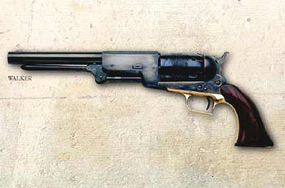

"Colt's Paterson and Walker Revolvers"

It's a story well known to all who have ever collected handguns. According to legend, the idea came to a young Sam Colt while serving as a Sailor aboard a vessel. Watching the operation of the ship's wheel, Colt visualized a cylinder with chambers holding powder and bullet, each chamber coming into battery behind a fixed barrel.

Col. Colt's prototype revolving pistol was nothing less than revolutionary. With one, a man could carry the equivalent of five single-shot pistols in one neat package. If he chose to carry a second revolver or a spare cylinder, he had an unheard of ten shots at his disposal. After having several prototypes made, Colt traveled to England where he patented his "improved revolver" in 1835.

In February 1836 Colt patented his design in the United States, and on March 5, 1836 signed contracts with New York investors. Thus was formed the "Patent Arms Manufacturing Company" of Paterson, New Jersey. The following day, March 6, 1836 the Alamo fell, it's
Defenders massacred and burned in a mass funeral pyre; an event which would be avenged ten years later at the muzzle of another famous Colt revolver, the .45 caliber Walker Model of 1847.

The initial Paterson revolvers were sold from an office, which had been established in New York City. Small "Pocket" pistols were offered in calibers .28, .31 and .34 with barrel lengths of from 2-1/2" to 4-3/4". Mid-sized pistols with barrel lengths of 4" to 6"were available in .31 and .34 calibers. "Holster" pistols, the largest models, were available in .36 caliber only with barrel
Lengths of 4" to 12". The majority of the Holster pistols had 7-1/2" and 9" barrels.

1 of 3

Colt Paterson & Walker revolvers, continued:

All Paterson revolvers were five-shot pistols and featured a unique trigger that retracted into the frame and unfolded when the weapon was cocked. Most came with a separate loading tool, however in 1839 a fixed under-barrel loading lever was made available to replace the loading tool. In all, only about 2,850 Paterson Colt revolvers were made.

During this time Colt also manufactured about 1,650 revolving cylinder carbines and rifles that were operated by means of a "ring" type lever. About 225 revolving multi-chambered shotguns
Were also produced. Colt sold fifty of his revolving rifles to the U.S. Government. These weapons were issued to the 2nd U.S. Dragoons for use fighting Seminole Indians in the Florida swamps. The poor combat performance of these rifles resulted in the government
Choosing not to purchase any further Paterson made firearms.

Regardless of the military's experiences, Paterson Colt firearms, particularly the pistols, were soon finding their way onto the western frontier. One of the most well known users of Paterson revolvers was the celebrated scout Kit Carson. Carson wore a brace of the weapons and fought Indians all along the Santa Fe Trail with them. Unfortunately for Colt, civilian sales of the Paterson firearms were not enough to keep the company financially solvent, and in 1842 "Patent Arms Manufacturing Company" went completely out of business.

Prior to going out of business, Patent Arms supplied 180 of their .36 caliber Paterson Colt "No. 5 holster pistols" with 9" barrels to the Republic of Texas Navy. When the Texas Navy was disbanded in 1843 the Paterson Colt pistols were given over to the Texas Rangers, a militia unit assigned to suppress hostile Indians and bandits. Each Ranger was issued two or three of the revolvers.

On June 8th, 1844 the Texas Rangers engaged in an event that would later result in the birth of the "Colt's Patent Firearms Company". Ranger Captain Jack Coffee Hays and a company of fourteen Rangers were returning to San Antonio after a patrol when they were attacked near the Pedernales River by a mounted force of 80 Comanche Indians. The Rangers immediately counter-attacked the Indians with their Paterson Colts. When the battle was over, the
Comanche’s fled leaving more than half of their warriors behind...dead.

Word of the Rangers great victory over the Comanche’s soon spread. For their part, the Rangers attributed their very survival to the firepower provided by the Paterson Colt revolver. One of the
Rangers who participated in "Hay's big fight" as it was called, was Samuel Walker. When the U.S. entered into war with Mexico in 1846, Walker joined a unit named the "U.S. Mounted Rifle Regiment". Walker convinced his superiors of the value of the revolver and was subsequently assigned to contact Samuel Colt and arrange for the delivery of new revolvers.

2 of 3
Colt Paterson & Walker revolvers, continued:

Walker collaborated with Colt on the design of a .45 caliber heavy "Dragoon" pistol, so named as it was intended to be carried on the saddle in pommel holsters. Through an arrangement with manufacturer Eli Whitney Jr., Colt delivered 1,000 of the pistols to the "U.S. Mounted Rifle Regiment". The first pair was delivered to Capt. Walker who was later killed in battle. After the war, many of these Colt-Walker Model 1847 revolvers were "liberated" by the mounted soldiers who had used them. Consequent demand for revolvers for self-protection became extremely strong as more and more Americans migrated into the newly opened and dangerous territories of the west, thus giving the newly formed "Colt Patent Firearm's Company" a solid business foothold for many years to come.

And so, that is the story of the Paterson Colt revolver, the patriarch of the "the gun that won the west", combat christened by legendary Frontier Scout Kit Carson and the courageous Texas
Rangers. For his part, Col. Colt never forgot his original pistol design or the valiant efforts of Captain Samuel Walker and the other Texas Rangers who made his pistols famous. Colt commemorated their courage by roll engraving the Pedernales River fight on the cylinders of his Dragoon model pistols.

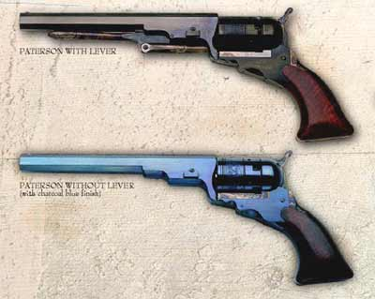

Prepared by Manny Silva, 2006. All rights reserved.

3 of 3

