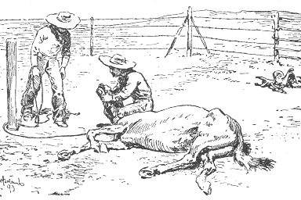

THE JACK POWERS GANG'S
ASSAULT ON THE RANCHO DANA

The 1850's in San Luis Obispo County were known as "The Bloody Fifties" due to the many robberies, murders and other atrocities being committed against the citizenry by bandits during that decade. Chief among the outlaws plaguing the county at that time was the "Jack Powers Gang."

Jack Powers was a Mexican War veteran and an expert horseman. He had arrived in Santa Barbara with U.S. forces in 1847. After the Mexican War he managed the de la Guerra stables. Eventually he and a San Luis Obispo bandit named Pio Linares formed a secret gang. They adopted the pirate motto, "DEAD MEN TELL NO TALES!” and killed their victims to keep them silent. All the while, they maintained their public persona in the community

In his book "Blonde Ranchero", Don Juan Dana tells how Jack Powers once attempted to ambush his brother, Don Guillermo Dana, while he was returning home from selling 300 head of cattle. Fortunately, Don Guillermo took an alternate route home and avoided being robbed. Later that day, Powers paid a visit to the Casa de Dana and discovered Don Guillermo had arrived safely home with the money. He left abruptly, leaving the family to wonder about his peculiar visit.

In the meantime, Don's Juan and Guillermo left on business, leaving the family in the care of a friend, Don Jesus Lopez. Later that evening, the Dana's gave shelter to a Yacqui Indian who had stopped by the rancho. The Indian was lodged in a storage cabin adjacent to the main house.

1 of 2

Powers Gang’s Assault on the Dana Adobe, continued:

Powers and the gang returned to Casa de Dana later that evening to carry out a robbery. However, the household was alerted when the Indian heard noises and peered out of the cabin door. One of the gang made an unsuccessful grab for him, causing a noisy disturbance. Hearing the commotion, Don Jesus looked out a window and saw the Indian running away. Realizing that something was amiss, Don Jesus bade the family to be quiet. The gang then opened fire upon the house when a servant looked out of the doorway. Don Jesus blew out the candles and took a defensive position at an upstairs window.

The household's firearms were locked in a room on the south side of the casa. Powers knew this and had taken special care to guard the room. When no one went for ammunition, Powers probably thought they had sufficient ammunition for a fight and decided to call off the attack. Years later, the details of the assault on the Casa de Dana were revealed when Vigilante's captured and tried some members of the Powers gang in San Luis Obispo.



Sources: "Blonde Ranchero”, by Don Juan Dana and "1883 History of San Luis Obispo County", by Myron Angel.

Written by Manny Silva, 2004. All rights reserved,

2 of 2

