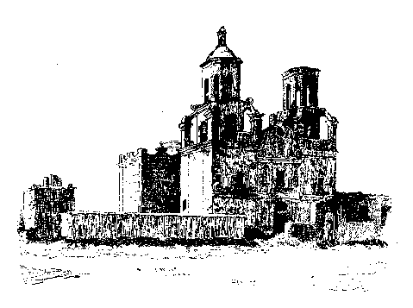

The Mission San Miguel Murders

In early 1847, an Englishman named Read brought his family to San Luis Obispo County from South America. They settled in Mission San Miguel, which had been abandoned sometime before by the Catholic Church. When gold was discovered in 1848 Read traveled to the gold country and worked as a miner. He returned to San Miguel in the fall of 1848 several thousand dollars richer. Although the Mission was very isolated, it was located along the El Camino Real and so Read established a store and an inn there with his wife, daughter, son-in-law, three children and a servant. By all accounts, Read was a kind host who had a reputation for unwisely showing off his wealth to strangers.

In October 1848 a group of American sailors deserted from their warship, which was at anchor in Monterey. They traveled south and eventually came to Mission San Miguel where Read took them in for the night. Read apparently made the unfortunate mistake of exhibiting his wealth to these desperate men. Later that night, the sailors conspired to murder the Read family and take their gold. Sometime after the Read family went to sleep the sailors attacked and murdered the entire household, including an infant whose head they bashed against a pillar in the corridor. The sailors then fled south with Read's gold.

The following day San Luis Obispo County ranchers John M. Price and F. Z. Branch, returning from a business trip, stopped at the Mission. When no one came out to greet them they became curious and decided to investigate. Inside they discovered the bodies of the Read family. Shocked by their grisly find, they went directly to Rancho El Paso de Robles and reported their discovery. Word was sent to San Luis Obispo and a party organized to return to the Mission to care for the dead and gather evidence.

The Mission San Miguel Murders, continued:

In the meantime a posse had been dispatched to track and capture the murderers. The tracking took several days but the murderous sailors were finally overtaken just south of Santa Barbara. A gunfight ensued and one of the posse was killed and others wounded, but all of the murderers were slain, including one who ran into the ocean and tried to swim away. That bandit was shot at until he sank beneath the waves, never to surface again. As for the other outlaws, it was decided they did not deserve a decent burial and their bodies were left where they fell to serve as "food for the vultures and coyotes".

Eventually, the Catholic Church reclaimed and reopened Mission San Miguel. Today, the Read family rests in an unmarked mass grave in a quiet corner on the grounds of Mission San Miguel, just a few of the many victims of San Luis Obispo County's violent and bloody past.

Sources: "1883 History of San Luis Obispo County" by Myron Angel; "1917 History of San Luis Obispo County" by Mrs. Annie L. Morrison and John H. Haydon; "Our Violent Past", New Times magazine, Sept. 9, 2004 issue.

Written by Manny Silva, 2004. All rights reserved.

